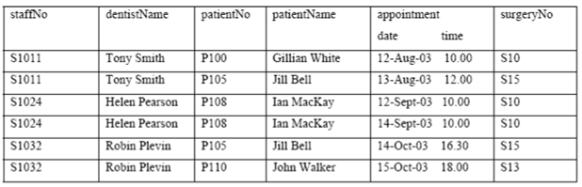

Identify all the FDs that hold on the above relation state.